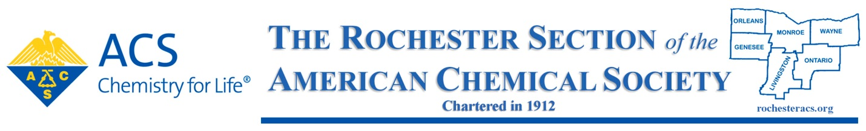

2024, Dr. Maryann Mendel Award for Volunteer Service to the Rochester ACS Section

SUPPORT FORM

Directions: Any individual, except a member of the award selection committee, may support only one nominee for this award in any given year. A maximum of two (2) support forms or letters are to be submitted for any one nominee. Please complete all fields.

Submittal process: Submit support forms or letters to:

Current Award Chair for Rochester Local Section

NOMINEE INFORMATION

First Name:
Middle Initial:
Last Name:
Email:

SUPPORTER INFORMATION

First Name:
Last Name:
Company or Institutional Affiliation:
Email:

SUPPORT INFORMATION

In the space below, paste or type a brief narrative summary describing how you know the nominee and the basis for your support of this nomination. Also, a separate letter may be written for this purpose and submitted electronically.

