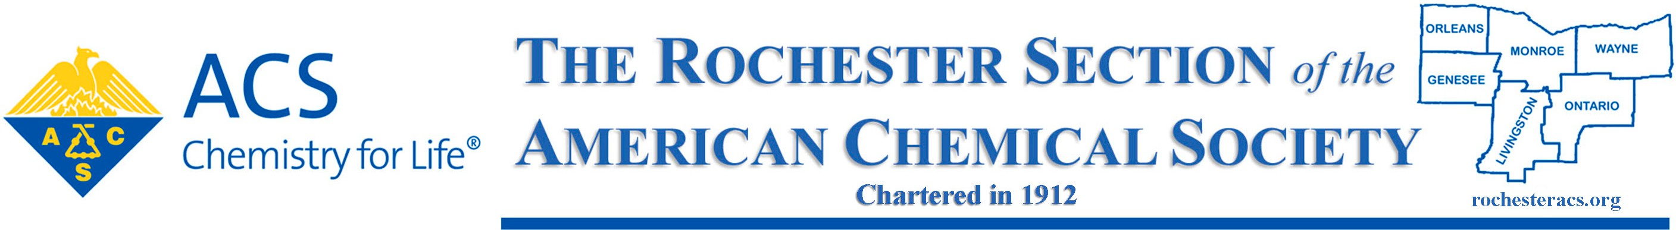

2024 Guidelines for the, Dr. Maryann Mendel Award for Volunteer Service to the Rochester ACS Section

Purpose: To recognize significant volunteer efforts of individuals who have served the Rochester Local Section of the American Chemical Society, contributing significantly to the vision and mission of the Society through their Local Activities.
Nature and Establishment: The award consists of a plaque to be presented at the Rochester Local Section’s Recognition Banquet by the Chair of the Local Section acknowledging the contributions of Society volunteers at the Local level. Dinner will be offered free of charge to the winner and a guest.
Rules of Eligibility: A nominee must be:
- A member of the American Chemical Society residing in the Rochester Local Section 6 county region.
- A member who has made significant contributions to the Rochester Region of the American Chemical Society.
Because the winner of this Local Section award will be nominated for the Northeast Region Volunteerism Award and, potentially, for the National ACS Volunteerism Award, it is important that the Local Section winner be recognized for a variety of activities including, but not limited to, the initiation or sponsorship of a singular endeavor or exemplary leadership in the Local Section, Region and on the National Level. Past and present members of the ACS Board of Directors and ACS staff are ineligible for this award.
Selection of Recipient: Nominations will be solicited from individuals of the Rochester Local Section. The awards committee will select the recipient. The award will be presented at this year’s Awards Dinner in October. The awards committee will nominate the winner to the Northeast Region of the American Chemical Society for their annual Regional Award for Volunteer Service.
Nominations: Nomination forms and seconding letters are needed and should be sent to:

Current Award Chair for Rochester Local Section

